Provider-Alias

<https://developer.hashicorp.com/terraform/language/providers/configuration>

Deep-research is key in creating you book-of-knowledge, having a view is also key. Stop moving around websites. But, learning certain things guarantee you that the questions which will be asked in interviews will fall in that basket. Don’t go for syllabus. They(interviewers) provide job description. Accordinly, certain topics has to be studied.

Instance type is not same across regions. T2.micro will be used as similar in Singapore though available in Mumbai. Every user-account in AWS has a instance capping, meaning the number of instances that a user can create in each individual region

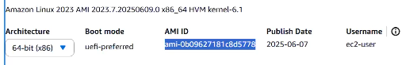

Table 1 Get-details at launch page of EC2 in each region

Goto VSCode >> Create folder=’alias-multipleprovider’

>> Add provider {} block in provider.tf

>> Add resource block to main.tf

* Terraform fmt

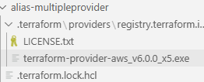

* Terraform plan
* Terraform apply –auto-approve



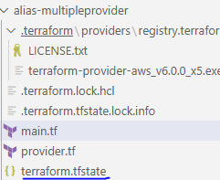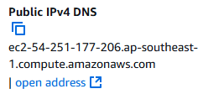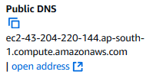

* Terraform destroy –auto-approve